Journal: Ecological Applications
Manuscript type: Article
Title: Hydrologically connected constructed wetlands meaningfully contribute to nutrient retention in Great Lakes watersheds

Authors:
Kenneth J. Anderson^{1*}, Lauren Brown², Mary Ellen Klukow¹, Raissa Marques Mendonca¹, Olivia Schloegel¹, Jakob Boehler³, David Dean⁴, Connor Gluck¹, Hana Esber¹, Ethan Glassman², Haley Hoehn⁵, Lindsay Horan⁶, Genna Hunt², Ewan Isherwood², Morgan Jutte⁵, Corbin Kohart², Austin Nainiger⁴, Alexandra Ochs¹, Ishfaq Rahman⁴, Madison Rice³, Leticia Sandoval⁴, Joseph S. Smith⁶, Zach Swan⁴, Christie Bahlai¹, Richard Becker⁴, Thomas Bridgeman⁴, David M. Costello¹, Stephen J. Jacquemin⁵, Janice Kerns⁸, Ganming Liu², Nathan Manning², Kevin E. McCluney², Silvia Newell⁷, Helen Michaels², W. Robert Midden², Ryan Winston⁶, Lauren Kinsman-Costello¹
* = corresponding author; kande120@kent.edu
Affiliations: 1. Kent State University, 2. Bowling Green State University, 3. Heidelberg University, 4. University of Toledo, 5. Wright State University, 6. Ohio State University, 7. Michigan Sea Grant, 8. Ohio Department of Natural Resources
Ask Chris Winslow, Kristen Fussel, Eric Saas, and Janice Kerns if they want to be authors

ADD YOUR NAME BELOW TO STATE YOUR APPROVAL AFTER READING:
Kenny Anderson, Morgan Jutte, Stephen Jacquemin, Ganming Liu, Haley Hoehn, Austin Nainiger, Mary Ellen Klukow, Ryan Winston, Ishfaq Rahman, Hana Esber, Leticia Sandoval, Bob Midden, Dave Costello, Kevin McCluney, Alexandra Ochs, Joey Smith

Open Research Statement:

Key words: Wetland restoration; Monitoring; Phosphorus; Nitrogen; Nutrient retention; Connectivity; HABs

Abstract
Eutrophication associated with non-point source nutrient loads is a global problem, and wetland construction is becoming increasingly common as a means of treating non-point source runoff. However, the effectiveness of wetlands at capturing nutrient runoff is highly variable, and our understanding of the drivers of nutrient retention in constructed wetlands is limited. To better understand how constructed wetlands retain nutrients, we monitored 24 wetlands in Ohio constructed through the H2Ohio initiative and created nutrient budgets for each wetland through a mass loading approach. Although hosphorus (P) release from wetland sediments, particularly in systems constructed on soils that may contain legacy P from historic fertilizer use, is a known risk, our data show that almost all constructed wetlands retained nutrients and that the magnitude of net annual retention was far higher than the magnitude of transient nutrient release. We found that inflowing volume set the maximum potential for nutrient retention as a strong driver of both retention and release. The concentration of nutrients in inflow water was not a strong predictor of nutrient retention when comparing across all wetlands studied, but when analyzing data from individual wetlands over time, inflow concentration often played an important role. By scaling up our data, we show that constructed wetlands can meaningfully contribute to regional water quality goals, but that contribution is far more effective if nutrient retention is optimized by connecting wetlands to sources of both water and nutrients.

1. Introduction:
Non-point source nutrient discharges, which originate across broad landscapes rather than from discrete discharge points, are a leading cause of aquatic ecosystem impairment around the world (Heisler et al. 2008, Smith and Schindler 2009, Wurtsbaugh et al. 2019). Excess nutrients drive eutrophication in aquatic habitats and can result in a variety of water quality issues, including harmful algal blooms (HABs; Anderson et al. 2002, Wurtsbaugh et al. 2019). The creation or restoration of wetlands is a common approach to mitigate non-point source nutrients because wetlands treat runoff from areas across the watershed and create a focal point where non-point source pollution can be concentrated and processed (Carpenter et al. 1998, Vymazal 2007, Weisner et al. 2016a).
Wetlands are nutrient-cycling hotspots that capture and process nutrients (McClain et al. 2003, Cheng and Basu 2017). Even small and seemingly disconnected wetlands can play major roles in landscape-scale rates of nutrient cycling when they are in high abundance (Marton et al. 2015, Cheng et al. 2023). The Grand Lake St. Marys watershed (located in northwest Ohio) has become emblematic of the effects of elevated nutrient levels in runoff and wetland-centric conservation practices; over 1,000 acres of wetlands have been constructed in the watershed over the past decade (Jacquemin et al. 2018). These wetlands treat more phosphorus (P) and nitrogen (N) than what their spatial footprints might suggest. For example, Coldwater Creek Restored Wetland has been in operation for about 10 years, and while its surface area is 0.2% of the sub-watershed, it has been shown to process nearly 5% of the total annual nutrient load (Jacquemin et al. 2025).

Constructed wetlands have demonstrated potential to successfully treat watershed nutrient loading; however, the designs of constructed wetlands with highest nutrient processing capacity are rooted in a deep understanding
of the underlying wetland nutrient retention mechanisms (Kadlec 2016, Ury et al. 2023). Wetlands initially capture nutrients by retaining water and reducing flow velocity, which allows time for sedimentation of particles and associated nutrients (Mitsch et al. 2014, Aziz and Van Cappellen 2021), adsorption of phosphate and ammonium to binding sites on sediment, and nitrogen removal (Collins et al. 2016). Dissolved nitrogen can be converted to N₂ gas and removed from the system via denitrification (the stepwise reduction of nitrate to N₂; Seitzinger et al. 2006) or anammox (anaerobic ammonia oxidation by nitrite; Koop-Jakobsen and Giblin 2009). Longer-term storage occurs through sediment trapping and nutrient uptake by vegetation, which transforms inorganic nitrogen and phosphorus into less bioavailable organic forms that may be stored by perennial plants across years(Silvan et al. 2004, Lucas and Greenway 2008). However, despite the clear potential of wetland restoration for nutrient retention, there are examples of restored wetlands that release nutrients rather than retain them (Ardón et al. 2010, Kinsman-Costello et al. 2014). This makes the study of what processes determine whether a wetland is a net ‘source’ vs. ‘sink’ particularly significant(Ardón et al. 2010, Steinman and Ogdahl 2011). Initial nutrient load to the wetland, the hydrologic residence time, invasive plant encroachment, and state factors (wetland age, temperature, etc.) all contribute to the wetland’s ability to reduce nutrient loads (Fisher and Acreman 2004, Sharp et al. 2021, Yousaf et al. 2021), but an understanding of how to manipulate important drivers to improve restoration of nutrient retention is still limited.
A variety of indices are often used as proxies to evaluate wetland restoration success, including vegetation diversity and cover, and hydrologic regime, but many of these may not accurately assess a wetland’s ability to retain nutrients (Fennessy et al. 2007). The drivers of nutrient retention in wetlands are not yet clearly understood, with highly variable rates of nutrient retention observed across a variety of studied wetlands (Land et al. 2016, Anderson et al. 2024). However, through nutrient budgeting methods, we know that wetlands that receive high nutrient loading consistently retain more phosphorus (Land et al. 2016, Ury et al. 2023), at least until P-binding sites are saturated (Jacquemin et al. 2025). Thus, a deeper understanding of how nutrient loading affects nutrient retention by constructed wetlands through connectivity to both runoff and nutrients is warranted to better support future wetland restoration. The restoration of wetland hydrologic connectivity affects multiple aspects of ecosystem function, but the end result can depend on specific restoration goals (Meng et al. 2020). A more thorough understanding of how connectivity affects nutrient retention will enable practitioners to optimize wetlands for nutrient retention and accurately assess water quality tradeoffs when creating wetlands for other primary goals such as wildlife habitat, flood abatement, or biodiversity.
To investigate the drivers of nutrient retention in wetlands, we (i.e., the Lake Erie and Aquatic Research Network's (LEARN) Wetlands and Water Quality Group) created empirically-based nutrient budgets for 24 constructed wetlands monitored across Ohio within the H2Ohio Wetland Monitoring Program. Nutrient budgets were calculated on both monthly and annual scales using a mass balance approach, collecting nutrient concentration and water volume data at the inlet and outlet of each wetland and calculating retention as the difference in nutrient load between the inlet and the outlet of the wetland. We aimed to address three main questions: 1. How much does connectivity of constructed wetlands to both runoff and nutrients contribute to their ability to retain nutrients? 2. What drives potential for nutrient release in constructed wetlands? 3. Can constructed wetlands feasibly contribute to landscape-scale nutrient retention goals? To evaluate the effects of connectivity on constructed wetland nutrient retention, we built linear mixed effects models with monthly measures of inflow volume and nutrient concentrations as predictors of nutrient retention across all 24 wetlands. To investigate the drivers of nutrient release potential, we built logistic regressions to assess the effects of nutrient load timing, inflow volume, and nutrient concentration on nutrient retention. To evaluate whether wetlands can feasibly contribute to landscape-scale nutrient load reduction goals, we built three hypothetical scenarios based on the nutrient retention estimates of the 24 monitored wetlands to extrapolate the total land area that would need to be converted to wetlands to meet the Lake Erie nutrient loading goal based on International Joint Commission targets (Ohio Environmental Protection Agency (EPA) 2023), explicitly considering 1) typical wetlands, 2) hydrologically connected wetlands, and 3) best-performing wetlands.

2. Methods:
2.1 Site Descriptions
We analyzed data from 24 wetlands built by conservation organizations with support from the Ohio Department of Natural Resources as part of the H2Ohio water quality initiative (“H2Ohio | Ohio.gov”; Figure 1), which has to date created or restored 529 wetlands and 21,727 acres across Ohio, especially focusing on the Maumee River Drainage Basin of Northwest Ohio. The goal of the H2Ohio program is to improve water quality throughout Ohio, with special focus on mitigating harmful algal blooms in Lake Erie through phosphorus load reduction (International Joint Commission 2014). Harmful algal blooms in Lake Erie are primarily driven by agricultural runoff (Michalak et al. 2013a); the state of Ohio and the Maumee River Drainage basin are over 50% and 80% agricultural land, respectively (Ohio Environmental Protection Agency 2023). Wetland restoration in Northwestern Ohio is especially relevant because the landscape was radically altered starting in the early 1900s when the Great Black Swamp, a wetland that covered 1 million acres of Northwestern Ohio, was drained for agricultural production (Mitsch 2017). Wetland restoration in the drainage basin had been sporadic until 2014, when the Toledo drinking water crisis spurred interest in restoration (Michalak et al. 2013b, Bingham et al. 2015), which led to the establishment of the H2Ohio Initiative and over $200 million in investments in wetland restoration across the state.
This analysis focused on data from the H2Ohio Wetland Monitoring program across 24 wetlands with sufficient data to calculate a nutrient mass balance budget (Kinsman-Costello et al. 2024). Twenty of the 24 wetlands had drainage areas with >60% agricultural land use, three of the four remaining had drainage areas with >70% urban land use, and one had a drainage area evenly split between forest and agriculture (Table S3). Source water varied between wetlands; 17 of the 24 wetlands received inflow from rivers, three had direct coastal connections with lakes, and six had direct agricultural tile drain inflows (Table S4).
2.2 Nutrient Budgets
2.2.1 Water Volume
Wetland nutrient retention was calculated using a mass balance budgeting approach, where inflowing and outflowing volumes of water were multiplied by inflowing and outflowing nutrient concentrations for each wetland. We describe any negative values for nutrient retention as nutrient release.

Nutrient load in=inflowing concentration x inflowing volume
Nutrient load out=outflowing concentration x outflowing volume
Nutrient retention=Nutrient load in-Nutrient load out

We calculated the nutrient retention for 24 wetlands from 2021 to 2025, for a total of 44 annual retention scenarios. Monitoring efforts at each wetland accounted for individuality of the wetland, logistical constraints, and labor availability. Specific details for each wetland are described in the supplemental material (SI: Nutrient budget methods). Cumulative monthly and annual water inflow and/or outflow volume was estimated at all 24 wetlands through either direct measurement of pumping rates (n = 3), stage-storage models (n = 13), estimation of flow based on the United States Department of Agriculture’s (USDA) Natural Resources Conservation Service’s (NRCS) curve number method (n = 1; USDA-NRCS 2004), watershed weighting using discharge from United States Geological Survey (USGS) gauges (n = 1), or water depth and weir equations (n = 7). For wetlands where either the inflow or outflow volume was not directly measured (n = 16), evapotranspiration was used to estimate the unmeasured value (Table S3).
Reference evapotranspiration (ET₀) values across wetlands were calculated from meteorological data using the Penman-Monteith Food and Agricultural Organization-56 method (Allen et al., 1998). Daily meteorological inputs, including minimum and maximum air temperature, minimum and maximum relative humidity, and wind speed at two meters height, were obtained from the nearest Ohio station of the Automated Surface Observing System (ASOS) network via the Iowa Environmental Mesonet (IEM). Where wind speed was only available at 10 meters, it was adjusted to the 2-meter reference height using the logarithmic wind profile equation (Allen et al. 1998). Atmospheric pressure was either obtained directly from ASOS station records or estimated from the elevation above sea level of the wetland using the barometric formula:
$$P=P_{0}⋅{(\frac{T_{0}-L⋅h}{T_{0}})}^{\frac{g}{R⋅L}}$$
where $P$ is the atmospheric pressure (kPa) at $h$, $P_{0}$ and $T_{0}$ are respectively the reference pressure and temperature at sea level, $L$ is the temperature lapse rate in the troposphere, $h$ is elevation above sea level (m), $g$ is the gravitational acceleration, and $R$ is the universal gas constant for air. Daily solar radiation (MJ/m²/day) was sourced from the National Aeronautics and Space Administration (NASA) Langley Research Center's Prediction of Worldwide Energy Resources (POWER) database using the wetland coordinates and the nasapower R package (Sparks 2018).
The Penman-Monteith FAO-56 equation combines a radiation term (r_{s}) and an aerodynamic term (r_{a}) to estimate the evaporative demand of the atmosphere over a hypothetical reference crop (Allen et al., 1998). Key intermediate variables (e.g., slope of the saturation vapor pressure curve, the psychrometric constant, mean saturation and actual vapor pressure) were calculated from the daily meteorological inputs and wetland-specific parameters (latitude, elevation). Soil heat flux density ($G$) was assumed to be negligible for daily time-step calculations, consistent FAO-56 guidance.
2.2.2 Nutrient Concentrations
Nutrient concentrations at the inlet and outlet of each wetland were sampled at least monthly for all wetlands except five that received or released water only via water control structures or during storm events; nutrient concentrations for those five wetlands were only collected during periods of flow into or out of the wetland. Of the other 19 wetlands, 12 were sampled monthly and seven were sampled every other week (i.e., primarily during baseflow or inter-event conditions). Eighteen wetlands received flow during storm events and, in addition to monthly sampling, had at least one storm-event sample (average of four storm samples per wetland), while six wetlands received inflows only through pumps or water control structures. Nutrient concentrations were assumed to stay constant between sampling points except during storm events, where they were changed based on storm concentration data available for each wetland (SI: Nutrient Budget Methods).
2.2.3 Estimating Wetland Runoff Prevention

The processing of new nutrients is not the only way that wetlands contribute to nutrient reductions across a watershed. To scale up our measured nutrient loading, we need to account for both the active treatment of nutrients by wetlands as well as how wetland creation alters nutrient loads by preventing nutrient loss from former agricultural areas. To account for the effects of replacing agricultural land with wetlands, including reduced fertilizer application and runoff, we assume wetlands are no longer fertilized and store water that would previously have runoff the landscape due to the disruption of tile drains. Pre-construction runoff data do not exist for the agricultural fields that were converted to wetlands, so we used data from the USDA-NRCS Edge of Field network for Northwest Ohio wetlands and applied the mean annual runoff estimate to the number of acres within each H2Ohio project that were taken out of agricultural production and converted to either wetland or restored upland habitat to estimate the mean runoff prevention (Hanrahan et al. 2019).
2.2.4 Upscaling Phosphorus Retention with Maumee TMDL Goals
To compare phosphorus retention rates to regional goals, we used the Maumee Watershed Total Maximum Daily Load (TMDL) guidelines (Ohio Environmental Protection Agency (EPA) 2023). Across the 2.5-million-acre portion of the Maumee watershed in Ohio, the TMDL aims to reduce phosphorus loading in March–July by a total of 1 million lbs (442 metric tons), with 20% of that reduction goal (~92 metric tons, or about 200,000 lbs P) allocated to systems that can function as sinks to non-point source P inputs, such as wetlands. To compare across a range of wetland construction practices, we compared three scenarios: “typical” H2Ohio wetlands (i.e., representative of commonly occurring wetlands across the portfolio, generally with sporadic connectivity to source water; 50th percentile of measured nutrient retention), hydrologically connected wetlands (75th percentile nutrient retention), and the best-performing wetlands (i.e., maximum retention recorded among 24 monitored wetlands). We first calculated total P retained for the year by adding the mean P runoff prevention to each wetland based on acreage converted from agriculture for that wetland (Hanrahan et al. 2019). We then calculated the HAB season retention by scaling the nutrient retention in lbs/acre for each scenario by the median percent nutrient retention (i.e., of total annual; 65% total phosphorus (TP) and 72% total nitrogen (TN)) during the HAB season across all monitored H2Ohio wetlands. Finally, we calculated the 50th, 75th, or maximum nutrient retention in lbs/acre across the monitored wetlands. To calculate the total wetland acreage needed to meet the TMDL goal within each modeled scenario, we divided the goal of 200,000 lbs P by the P retention rate in lbs per acre.
To compare nitrogen retention rates to regional goals, we used the proposed nitrogen goals from Paerl et al. (2024). They propose a 40% reduction of nitrogen compared to the 2008 baseline for the Maumee Watershed (~18 million lbs for the Ohio portion). We assume that load reductions for nitrogen would be allocated among non-point source sinks and source management similarly to the TMDL goals for phosphorus, and thus designated 20% of the total load reduction target (92 metric tons phosphorus / 442 metric tons phosphorus); for a total reduction goal of 3.7 million lbs nitrogen. To calculate the total wetland acreage needed to meet this 40% reduction in nitrogen loads, we used the same scenarios as those described above for phosphorus.

2.3 Statistical Analysis
To investigate relationships between nutrient retention, water volume, and nutrient concentration, we constructed linear mixed-effects models, analysis of covariance (ANCOVA), and logistic regressions in R (R Core Team 2024). To compare our monthly data across wetlands and understand management relevant relationships between retention, concentration, and volume, we used linear mixed-effects models with wetland identity as a random effect. We log-transformed retention and inflow volume to better model the non-linear relationship between the two variables. The model was structured as nutrient retention ~ [inflow volume OR inflow concentration] + (1 | wetland).
Nutrient retention was calculated in part using inflow volume and inflowing nutrient concentrations, which we then used as predictors of nutrient retention. These values are valid predictors because we are investigating the effect of the wetland, which cannot change the influent volume or concentration, only the concentration and volume leaving (which we do not use as predictor variables). Additionally, the influent composition and volume are critical factors for nutrient retention in wetlands (Sharp et al. 2021, Ury et al. 2023). To test the applicability of our model of inflow volume as a predictor of nutrient retention, outside the bounds of the original dataset, we performed a leave-one-out analysis. For this analysis, we sequentially removed one wetland and then ran two models: 1. A model predicting nutrient retention without the removed wetland included in the model and 2. A model predicting nutrient retention of the removed wetland. The first model allowed us to test how important each individual wetland was for building the model. The second model allowed us to test how well the model predicted nutrient retention in wetlands not included in the model. To evaluate model performance, the RMSE was calculated for the model with the wetland removed and the model predicting the removed wetland. RMSE values were calculated using version 0.1.4 of the Metrics package (Hamner et al. 2018) in R.
To analyze how concentration and volume affect individual wetlands, we used ANCOVA to model the interaction of concentration, inflow volume, and wetland identity. We modeled the slope for the relationship between nutrient retention and inflow volume and concentration for each wetland. We log-transformed inflow volume, concentration, and retention so that slopes of concentration and inflow volume would be comparable. We structured the model as nutrient retention ~ (inflow volume + inflow concentration) * Wetland identity.
To identify drivers of nutrient release, we built a logistic regression model with a binary response of either “retention” or “release” for each month. We structured the model as a binary for release ~ inflow volume + concentration in + month.

3. Results:
3.1. Nutrient Retention
We observed net annual nutrient filtration in most wetlands, net annual TP release in two wetlands, and net annual TN release in three wetlands across all years monitored (including the two that released TP; Table S1). TP retention ranged from –11 lbs/year to 1732 lbs/year, with a mean (± standard deviation) of 113 lbs/year (±280), and a median of 25 lbs/year. TN retention ranged from -549 lbs/year to 7345 lbs/year, with a mean (± standard deviation) of 1416 lbs/year (±1812) and a median of 711 lbs/year (Table 1). Of the 528 wetland-months (unique combinations of wetland and month), 60% (313 wetland-months) indicated net TP retention, 13% (72 wetland-months) indicated net TP release, and 27% (143 wetland-months) indicated no net release or retention of P. Within that same dataset, 64% (336 wetland-months) indicated net retention of N, 9% (49 wetland-months) indicated net release of N, and 27% (143 wetland-months) indicated no net release or filtration of N. For most wetlands, retention outweighed release in terms of both total mass and number of months. Retention of both TP and TN, across all wetlands, occurred primarily during spring (March through May) and summer (June through August), with 38% of TP and 45% of TN filtered in the spring and 38% of TP and 36% of TN filtered in the summer (Figure 2A and C). Dissolved nutrients were similarly retained, primarily during spring, with 34% of dissolved reactive phosphorus (DRP) processed in the spring and 39% in the summer, 44% of nitrite+nitrate processed in the spring and 38% in the summer, and 18% of total ammonium nitrogen (NH₄) processed in the spring and 58% in the summer. The efficiency of nutrient retention varied widely across all wetlands studied (Table S2). We have currently collected 3 or more years of data at 5 of the 24 total wetlands. There were no consistent trends across years within any of the 5 wetlands. Wetland nutrient retention decreased for most monitored wetlands in 2024 but then increased in 2025. The efficiency of nutrient retention varied from year to year, but there was not a consistent or significant directional trend across wetlands (Figure S2).
3.2 Drivers of Nutrient Retention Across Wetlands
Monthly nutrient retention and release across wetlands were significantly related to inflow volume. Across months and wetlands, the log-scale total monthly mass of both TP and TN removed (positive retention values) and/or released (negative retention values) was strongly related to the log-scale monthly inflow volume (TP: R² = 0.83 for retained, R² = 0.59 for released; TN: R² = 0.8 for retained, R² = 0.58 for released; Figure 3). While there is a significant relationship between retention and concentration for both TP and TN, the variability explained therein is limited compared to volume (TP: R² = 0.01, TN: R² = 0.15; Figure 3). We found similar relationships between inflow volume and retention of dissolved nutrients DRP (R² = 0.76), NO_{x} (R² = 0.70), and total ammonium nitrogen (NH₄, R² = 0.76), as well as between inflow volume and release of dissolved nutrients for DRP (R² = 0.52), TN (R² = 0.48), NO_{x} (R² = 0.45), and ammonium nitrogen (R² = 0.28). Similarly, significant but weak relationships existed between concentration and filtration for DRP (R² = 0.03), NO_{x} (R² = 0.03), and NH₄ (R² = 0.00).
To ensure that the relationship between inflow volume and nutrient retention was both not reliant on an individual wetland to drive the pattern and also robust to independent data, we remade the model without wetland as a random effect and sequentially removed wetlands from the database to perform a leave-one-out analysis. The exclusion of individual wetlands did not change the model RMSE by more than 0.04 log units for TP retention, or by more than 0.07 log units for TN retention (Figure S1A, C). The model performed well when predicting removed sites with a median error of 0.5 log units and a maximum error of 1.0 log units for TP retention, and median of 0.54 log units and a maximum of 1.3 log units for TN retention (Figure S1B, D). The model consistently predicts independent data within an order of magnitude, and typically within half an order of magnitude.

3.3 Drivers of Nutrient Retention Within Wetlands
While we found that inflow volume had a stronger correlation with nutrient retention than concentration across all wetlands studied, individual wetlands’ nutrient concentrations often played an important role. We used ANCOVA to understand how the impact of concentration and volume varied across projects. We found that log(inflow volume) and log(nutrient concentration) were both significant predictors for total retention across all nutrients measured (TP, TN, DRP, NOx, NH4; Table S5). ANCOVA results indicate that within individual wetlands, concentration often plays an important role in determining nutrient retention, with similar slopes between log(inflow concentration) and log(inflow volume) and for some wetlands higher slopes for log(concentration) than volume (Figure 4).
3.4 Drivers of Nutrient Release
To understand patterns of nutrient release, we performed a logistic regression with month, inflowing concentration, and inflow volume as predictors of whether nutrients were retained or released. Inflow nutrient concentration was the only significant predictor of nutrient release for both TP (Logistic Regression; z = -3.74, p < 0.01) and TN (Logistic Regression; z = -4.13, p < 0.01), with higher probability of release at lower nutrient concentrations (Figure 5). Neither month (TP: z = -1.0, p = 0.3, TN: z = 0.37, p = 0.7) nor inflow volume (TP: z = -0.16, p = 0.9, TN: z = -0.62, p = 0.5) were significant predictors of nutrient release. Inflow TP concentrations during months with net release of TP (mean 0.16±0.15 mg/L) were significantly lower than during months with net retention of TP (mean 0.39±0.40 mg/L; Welch Two-Sample t-test, t = 7.4, p < 0.01). Inflow TN concentrations during months with net releases of TN (mean 2.11±1.66 mg/L) were significantly lower than during months with net retention of TN (mean 5.08±4.78 mg/L; Welch Two-Sample t-test, t = 7.9, p < 0.01).
3.5 How Much Wetland Area Is Needed to Meet Nutrient Retention Goals?
We constructed three scenarios to address how many wetlands would need to be constructed to meet the Maumee Watershed TMDL goal of 200,000 lbs P retained using wetlands. The total P retention estimates calculated for the HAB season, accounting for both wetland retention and runoff prevention, were 1.95 lbs/acre for typical wetlands (50th percentile), 5.2 lbs/acre for connected wetlands (75th percentile), and 114 lbs/acre for the best performing wetlands (100th percentile; Table 2). This means that 120,000 acres of typical wetlands, 40,000 acres of connected wetlands, or 2,000 acres of the best performing wetlands could annually retain enough P during the HAB season to meet Maumee Watershed TMDL load reduction goals allocated to “Enhancing Non-Point Source Sinks”.
Similarly, we calculated that the total nitrogen retention during the HAB season, accounting for both wetland retention and runoff prevention, was 41.8 lbs/acre for typical wetlands, 140.5 lbs/acre for connected wetlands, and 629.1 lbs/acre for the best performing wetlands (Table 2). This means that 88,000 acres of typical wetlands, 26,000 acres of connected wetlands, or 6,000 acres of the best performing wetlands would be needed to meet analogous nitrogen load goals suggested for the Ohio portion of the Maumee watershed (Paerl et al. 2024).
In total, the conversion of 1% of current agricultural land (2.6 million acres) in the Maumee River watershed to hydrologically connected wetlands (75th percentile wetlands) would meet TMDL goals for wetland contribution to P retention during the HAB season and would nearly double proposed reductions for N.
4. Discussion:
4.1. Hydrologic connectivity and nutrient retention
We found that all H2Ohio wetlands retain nutrients on an annual scale, but low-magnitude, transient releases are common across these wetlands. Meta-analyses have shown that wetlands typically retain nutrients (Land et al. 2016, Ury et al. 2023), but ours is one of the largest studies on nutrient retention with consistent monitoring methods across all constructed wetlands. We found a strong relationship between inflow volume and nutrient retention, as well as a strong relationship between inflow volume and nutrient release across H2Ohio constructed wetlands. This suggests that inflow volume sets the scale for nutrient retention: higher volumes of water lead to higher retention or release. While we did not find that concentration of either phosphorus or nitrogen were significant predictors of nutrient retention across these wetlands, we did find that it was often important, and occasionally more important than volume, as a predictor of nutrient retention within individual wetlands over time. A higher water volume likely plays a role both by determining the total mass of nutrients delivered to the wetland and by controlling the residence time within the wetland (Sharp et al. 2021, Ury et al. 2023).
Although the amount of water that can be treated across wetlands does vary, the holding capacity of an individual wetland does not change. When a wetland receives too much water and its residence time is shortened, nutrient retention efficiency decreases because the water is not slowed enough to allow settling, and there is less time for sorption of phosphate, plant uptake, and microbial denitrification (Jiang and Mitsch 2020, Hambäck et al. 2023). However, the scale of change in volume across wetlands is important in this context, because differences in volume, and thereby load, can outweigh reductions in efficiency. For example, a wetland that retains 99% of 10 lbs of phosphorus (9.9 lbs) is contributing less to watershed-scale nutrient retention than a wetland that retains only 10% of 100 lbs of phosphorus (10 lbs; Kadlec 2016).
Understanding how major storm events, when residence times are short and large volumes of water enter wetlands, affect nutrient retention dynamics is critical for accurately calculating nutrient budgets (Anderson et al. 2024). Storm events are when most of the water and nutrients move across the landscape in agricultural drainages and deliver high concentrations of nutrients for wetlands to retain (D’Amario et al. 2021, Johnson et al. 2024). While wetlands receiving continuous flow have often been found to be more effective than flood pulse wetlands (Díaz et al. 2012), many constructed wetlands are designed to only receive water during storm events, making their ability to capture high volumes of water in a short period of time even more important. Our analysis supports the importance of capturing data during storm events, but our interpretation of our storm data is limited by the infrequency of nutrient sample collection during storm events and a lack of understanding of the relationship between concentration and discharge at both the inlet and outlet of wetlands during storms . Missing storms could lead to underestimates of nutrient retention if high concentration storm inflows due to agricultural runoff are missed during sampling (D’Amario et al. 2021). Our understanding of nutrient retention in constructed wetlands is also limited by the lack of long-term data (Anderson et al. 2024). Three of the four years of H2Ohio monitoring have taken place during droughts, limiting our understanding of how these wetlands function during wetter conditions, which are projected to become more frequent throughout the 21st century (Prein and Mearns 2021). Additionally, three to four years of data cannot accurately predict long-term trends, especially with newly constructed wetlands that are rapidly developing (Craft 1996) and building up stores of P which might subsequently be released (Sharpley et al. 2013). Similarly, vegetation communities change over time, and as vegetation grows and decays, soil carbon will also rapidly change, which can structure microbial communities and lead to either uptake or release of phosphorus and nitrogen (Hossler and Bouchard 2010, Wang et al. 2023).
.
4.2 Drivers of nutrient release
Nutrients in wetlands are stored in water, sediment, or vegetation; release into the water column from sediments commonly occurs due to changing microbial or redox dynamics and/or the decomposition of organic matter (McLatchey and Reddy 1998, McCarthy et al. 2007, Steinman et al. 2012). We found no monthly or seasonal patterns that explained why wetlands released nutrients when they did, but we did find that nutrient release was more likely during low-nutrient-concentration inflows. This supports previous analyses suggesting that diffusion gradients between sediments and surface water may play an important role in determining when wetlands release nutrients (Steinman et al. 2012, Matisoff et al. 2016, Back et al. 2025). It is also well documented that drying and rewetting of sediment can lead to nutrient release (Aldous et al. 2005, Kinsman-Costello et al. 2014), which could contribute to the pattern of release during low concentration if rewetting events are associated with low concentration inflows. Longer residence time during dry periods likely also contributes, but residence time was not directly calculated for all wetlands in this study. However, multiple studies have shown that major storm events are not necessarily associated with nutrient release from wetlands, further supporting low incoming concentration as a potential cause of releases (Jordan et al. 2003, Tanner and Sukias 2011, Dunne et al. 2015). Alternatively, there may be consistent but low levels of release that lead to net releases only when incoming nutrient concentrations are low enough that there is little potential for retention.
4.3 Landscape scale retention
Our analysis, which contextualizes regional phosphorus and nitrogen reduction goals via three wetland scenarios (i.e., typical wetlands, connected wetlands, and best performing wetlands), highlights the importance of further study of features that can optimize nutrient retention in both new and existing wetlands. The H2Ohio program has created, restored, or enhanced over 20,000 acres of wetlands and associated habitat across Ohio . Depending on optimization of wetlands’ ability to retain nutrients, 20,000 acres could represent either half of the 40,000 acres of connected wetlands needed to meet TMDL phosphorus goals or only a fifth of the 120,000 acres of typical wetlands needed; however, it is important to note that not all 20,000 acres of constructed wetlands are within the Maumee watershed. Both typical and hydrologically connected wetlands are more effective at meeting nitrogen goals than phosphorus goals, with 30% less acreage of typical wetlands and 50% less acreage of connected wetlands needed to meet nitrogen water quality goals. The amount of wetland acreage needed to meet restoration goals is similar for both nitrogen and phosphorus in typical and hydrologically connected wetlands, but our most effective wetlands for phosphorus retention suggest greater potential to optimize phosphorus retention than there is nitrogen retention. If we had only our most effective wetlands for phosphorus retention, we would need only 2,000 acres of wetland compared to 6,000 acres of the most effective wetlands at retaining nitrogen.

Our data supports past efforts that have shown that optimizing wetlands (either by modifying existing wetlands or constructing new wetlands) through ensuring high connectivity to source water can determine the effect of wetlands on landscape-scale nutrient removal (Weisner et al. 2016b). Wetlands can be highly effective tools for nutrient retention across agricultural landscapes, but their effectiveness depends on an understanding of the hydrologic and biogeochemical drivers of nutrient retention at individual wetlands (Cheng and Basu 2017, Jacquemin et al. 2025). *starting to just dump ideas here, please don’t read to edit yet * The Maumee TMDL includes stream and wetland restoration and floodplain reconnection projects to be practices that enhance nonpoint source sinks for P on the landscape (citation). Although broadly labeled “wetland restoration,” projects supported through H2Ohio program include restoration of streams, floodplain reconnections, and construction and restoration of wetlands. In practice, many H2Ohio Projects integrate a combination of stream, wetland and floodplain connection features. While the scenarios presented here affirm that, generally, the restoration and construction effort necessary in terms of area converted is realistic, they do not account for the important factors of how and where wetland infrastructure is implemented throughout the watershed will affect nutrient loads, nor how the aging of newly constructed and restored systems and year-to-year variability will alter nutrient retention rates over time. Our data unequivocally demonstrate that wetland restoration is a meaningful, realistic, cost-effective, and necessary component of watershed-scale efforts to mitigate HAB-fueling nutrient loads, and that ongoing improvements to wetland restoration, construction, and management are a worthwhile investment [this might be too on the nose and advocacy-y for a paper, I will think of less value-laden words, especially without an economic analysis included.] to achieve basin wide goals.
5. Conclusion
We used data from the H2Ohio Wetland Monitoring Program to create mass loading nutrient budgets for 24 constructed wetlands across Ohio. Our analysis shows that wetlands retain nutrients and that while intermittent releases were not uncommon, their magnitude was far smaller than the retention by each wetland on an annual scale. Comparing our monitoring results to regional goals for capturing non-point source pollution shows that building hydrologically connected wetlands can contribute to landscape scale nutrient retention. The variation in nutrient retention highlights the importance of monitoring newly constructed wetlands for adaptive management. The high range in effectiveness in wetlands highlights that increasing connectivity and optimizing wetland nutrient retention has the potential to significantly improve the ability of wetland to contribute to landscape scale nutrient retention. This study highlights the importance of wetlands receiving water when comparing across the entire range of wetlands but also highlights how inflowing volume doesn’t always increase the effectiveness of individual wetlands. Future studies should further investigate the features that lead individual wetlands to better retain nutrients.

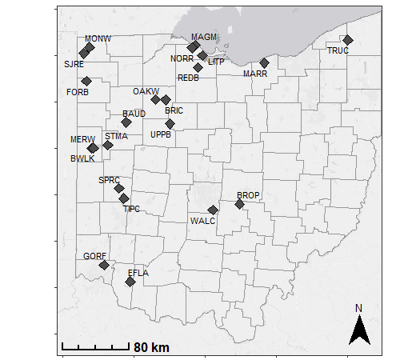
Figures:
Figure 1. Map of 24 wetland restorations where inflowing and outflowing volumes and nutrient concentrations were monitored to build nutrient budgets
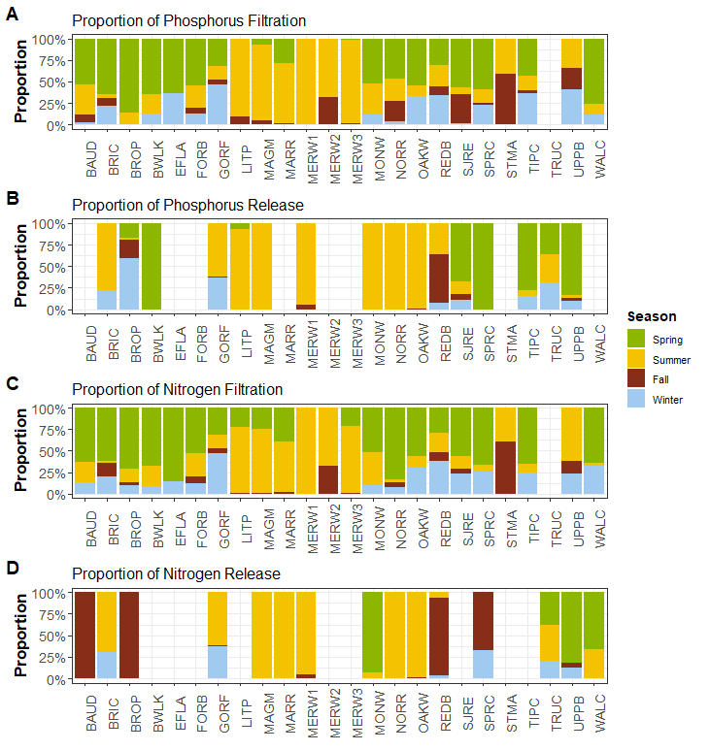
Figure 2. Proportion of total phosphorus and total nitrogen retention and release across seasons. Note this figure only shows the relative proportion of the total annual retention or release that occurred across each season, not the magnitude. Data are grouped seasonally: fall (September 1–November 30), winter (December 1–February 28), spring (March 1–May 30), summer (June 1–August 31). For full wetland names see (Lake Erie and Aquatic Research Network (LEARN): Wetlands and Water Quality Group (H2Ohio Wetland Monitoring Program) 2026).
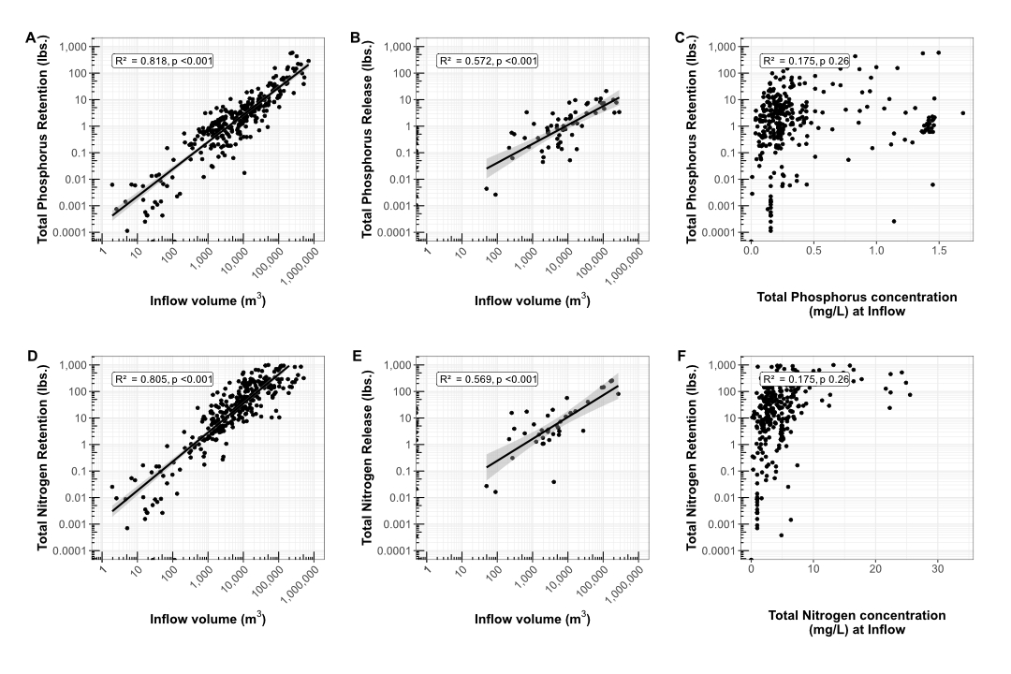
Figure 3. Relationships between monthly inflow volume in meters cubed, and monthly retention and release for both total phosphorus (A-C) and total nitrogen (D-F), as well as relationships between retention and monthly inflowing concentration for total phosphorus and total nitrogen. Relationships are presented as linear mixed effects models with wetland as a random factor. Data on inflow volume and nutrient retention are presented on a log scale; minor axis ticks show the log progression on each axis.

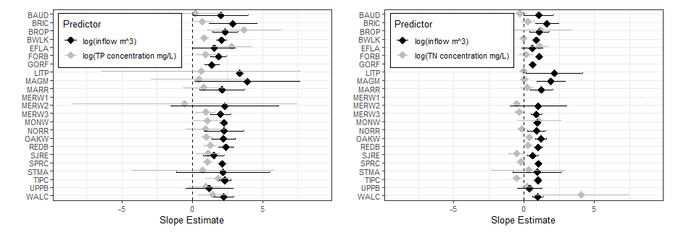
Figure 4. ANCOVA slope estimates for both log(inflow volume) and log(nutrient concentrations mg/L) at each wetland. The models for both TP and TN were constructed with additive effects of volume and concentration and an interactive effect with wetland identity: log(nutrient retention) ~ log(nutrient concentration) + log(inflow volume) * Wetland.

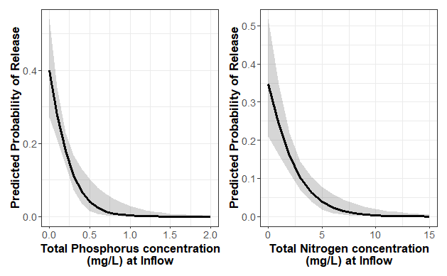
Figure 5. Probability of nutrient release based on inflow concentrations of total phosphorus and total nitrogen from logistic regressions. For both total phosphorus and total nitrogen, concentration was a significant predictor of release, whereas inflowing volume and month were not.

Tables:
Table 1. Nutrient retention across all monitoring years for H2Ohio wetlands. Retention was calculated by measuring inflowing and outflowing nutrients to 24 different wetlands for between one and four years. Nutrient budgets were calculated for total phosphorus (TP), total nitrogen (TN), dissolved reactive phosphorus (DRP), nitrite+nitrate (NO_{x}), and total ammonium nitrogen (NH₄). Mean, median, and range are presented in both total lbs retained, and in lbs/acre of restored wetland.
 | Mean Nutrient Retention (lbs) | Median Nutrient Retention (lbs) | Range of Nutrient Retention (lbs) | Mean Nutrient Retention (lbs/acre) | Median Nutrient Retention (lbs/acre) | Range of Nutrient Retention (lbs/acre)
Total P | 113 | 25 | -11 to 1733 | 19 | 1 | -1 to 495
Total N | 1417 | 712 | -549 to 7345 | 127 | 25 | -32 to 968
DRP | 36 | 15 | -10 to 295 | 3 | 1 | -1 to 35
Nox | 1170 | 329 | -2 to 6904 | 91 | 18 | 0 to 756
NH4 | 42 | 4 | -75 to 421 | 3 | 0 | -21 to 36

Table 2. Wetland acres needed to meet the TMDL “enhance nonpoint source sinks” phosphorus reduction goal and proposed co-reduction goals for nitrogen for three different scenarios: Typical wetlands (using 50th percentile nutrient retention values), Connected wetlands (using 75th percentile nutrient retention values), and the best performing wetlands (using the maximum nutrient retention values). Total P retention is calculated as the P retention by wetlands plus the runoff prevention estimated based on the proportion of wetland converted from agriculture. Median phosphorus (P_ retention during the HAB season was 65% of annual retention and median nitrogen (N) retention was 72%, so here 65% of total P retention, and 72% of total N retention are used.
Scenario | Total P retention (lbs P / acre during HAB season) | Total N retention (lbs N / acre during HAB season) | Wetland acres needed to meet TMDL wetland goal for TP | Wetland acres needed to meet co-reduction TN goals
1. Typical Wetlands (50th percentile) | 1.65 | 41.8 | 120,000 | 88,000
2. Connected Wetlands (75th percentile) | 4.78 | 140.5 | 40,000 | 20,000
3. Best performing Wetlands (Maximum) | 113.75 | 629.1 | 2,000 | 6,000

Supplemental Figures
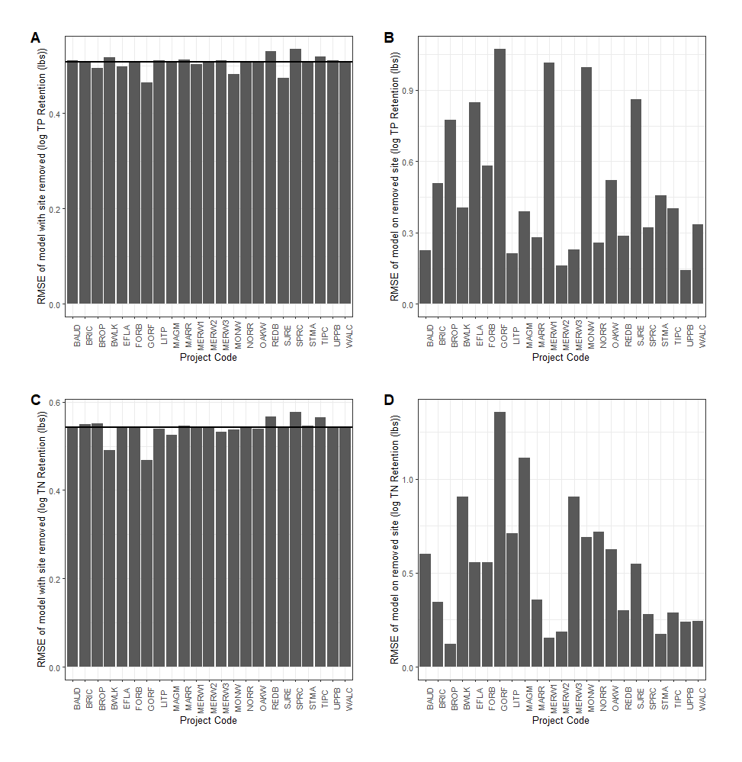
Figure S1. Root mean square error (RMSE) of linear models of monthly TP retention ~ inflow volume. Each bar represents the RMSE for a) the model with the listed wetland removed or b) the performance of the model predicting TP retention of the removed wetland. The horizontal line in A and C is the RMSE of the full model.

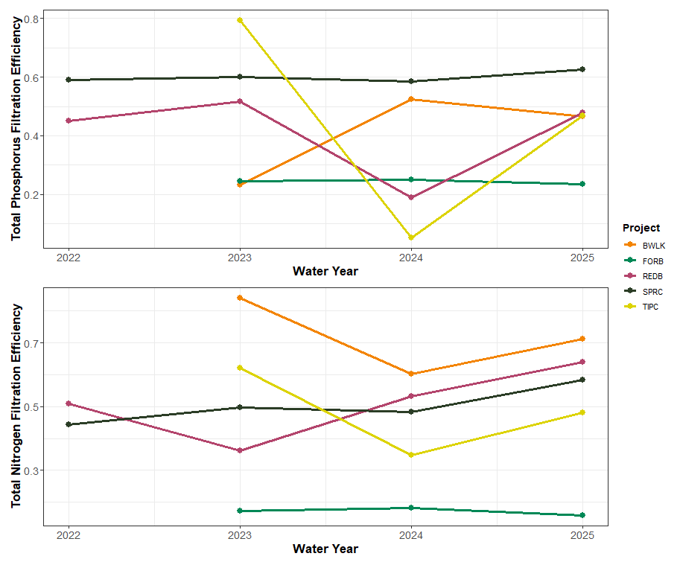
Figure S2. Change in annual phosphorus and nitrogen filtration efficiency over time across the five wetlands with three or more years of data. Nutrient filtration efficiency was calculated as the annual mass of the nutrient filtered divided by the annual total mass of that nutrient that entered the wetland.
Table S1. Nutrient retention across all monitoring years for H2Ohio wetlands. Retention was calculated by measuring inflowing and outflowing nutrients to 24 different wetlands for between one and four years. Nutrient budgets were calculated for total phosphorus (TP), total nitrogen (TN), dissolved reactive phosphorus (DRP), nitrite+nitrate (NO_{x}), and total ammonium nitrogen (NH₄).
 |  |  |  | Retention (lbs of Phosphorus or Nitrogen)
Wetland | Restored Wetland (acres) | Water Year | Inflow volume (m³) | Total P | Total N |  | DRP | NO_{x} | NH₄
BAUD | 12 | 2025 | 301,375 | 50 |  | 864 | 54 | 716 | 9
BRIC | 11 | 2025 | 77,712 | 9 |  | 234 | 1 | 162 | 1
BROP | 5 | 2023 | 1,185,291 | 24 |  | 3,294 | 21 | 2,838 | 65
 |  | 2024 | 1,214,616 | 59 |  | 4,266 | 22 | 3,781 | 94
BWLK | 27 | 2023 | 195,394 | 41 |  | 7,345 | 25 | 6,831 | 203
 |  | 2024 | 438,735 | 238 |  | 5,513 | 120 | 4,976 | 0
 |  | 2025 | 177,637 | 86 |  | 5,627 | 57 | 4,803 | -5
EFLA | 3.5 | 2024 | 867,904 | 1,733 |  | 3,388 | 122 | 647 | 127
 |  | 2025 | 1,434,010 | 611 |  | 1,378 | 61 | 198 | -75
FORB | 5 | 2023 | 15,657 | 12 |  | 29 | 0 | 3 | 0
 |  | 2024 | 10,866 | 9 |  | 21 | 0 | 2 | 0
 |  | 2025 | 20,858 | 15 |  | 36 | 0 | 2 | 0
GORF | 1 | 2024 | 115 | 0 |  | 0 | 0 | 0 | 0
 |  | 2025 | 613 | 0 |  | 0 | 0 | 0 | 0
LITP | 95 | 2025 | 149,847 | 38 |  | 1,177 | 16 | 1,221 | 134
MAGM | 173 | 2024 | 149,224 | 16 |  | 290 | 2 | 8 | 11
 |  | 2025 | 623,492 | 219 |  | 729 | 119 | 227 | 362
MARR | 16 | 2025 | 8,073 | 3 |  | 13 | 3 | 16 | 0
MERW1 | 15 | 2025 | 57,229 | -11 |  | -55 | 9 | 1 | -14
MERW2 | 30 | 2025 | 54,504 | 13 |  | 219 | 7 | 1 | -2
MERW3 | 4.5 | 2025 | 263,764 | 115 |  | 2,528 | 22 | 1,810 | 61
MONW | 10 | 2024 | 11,476 | 9 |  | -33 | -10 | -2 | NA
 |  | 2025 | 18,838 | 29 |  | 184 | 15 | 85 | NA
NORR | 23 | 2025 | 151,978 | 13 |  | 648 | 3 | 532 | 43
OAKW | 20 | 2024 | 7,621 | 4 |  | 106 | 1 | 88 | 0
 |  | 2025 | 52,884 | 28 |  | 694 | 8 | 576 | -2
REDB | 25 | 2022 | 108,974 | 27 |  | 396 | 7 | 260 | 2
 |  | 2023 | 109,881 | 20 |  | 178 | 4 | 126 | 4
 |  | 2024 | 80,006 | 7 |  | 212 | 1 | 167 | 2
 |  | 2025 | 75,195 | 19 |  | 302 | 0 | 279 | 0
SJRE | 33 | 2024 | 66,141 | 1 |  | 1,075 | 14 | 750 | 28
 |  | 2025 | 134,681 | 4 |  | 1,968 | 28 | 1,701 | 89
SPRC | 25 | 2022 | 401,810 | 153 |  | 2,435 | 76 | 1,890 | 37
 |  | 2023 | 278,428 | 103 |  | 1,952 | 57 | 1,684 | 31
 |  | 2024 | 194,282 | 68 |  | 1,394 | 33 | 1,130 | 20
 |  | 2025 | 334,554 | 110 |  | 2,864 | 48 | 2,049 | 53
STMA | 31 | 2025 | 370,350 | 252 |  | 2,385 | 95 | 3 | 421
TIPC | 10 | 2023 | 256,538 | 112 |  | 1,569 | 64 | 1,745 | 25
 |  | 2024 | 269,018 | 6 |  | 1,032 | 13 | 987 | 63
 |  | 2025 | 323,796 | 73 |  | 1,791 | 43 | 1,828 | 35
TRUC | 30 | 2025 | 0 | -3 |  | -56 | -1 | -1 | -9
UPPB | 30 | 2025 | 55,267 | 2 |  | 115 | -1 | 59 | 3
WALC | 17.4 | 2023 | 770,819 | 166 |  | -549 | 117 | 380 | -24
 |  | 2024 | 1,687,419 | 497 |  | 4,789 | 295 | 6,904 | -20

Table S2. Nutrient retention efficiency across all monitoring years for H2Ohio wetlands. Retention was calculated as the proportion of incoming nutrients that were not detected leaving the system. Nutrient retention efficiency was calculated for total phosphorus (TP), total nitrogen (TN), dissolved reactive phosphorus (DRP), nitrite+nitrate (NO_{x}), and total ammonium nitrogen (NH₄).
 |  |  |  | Retention (lbs of Phosphorus or Nitrogen)
Wetland | Restored Wetland (acres) | Water Year | Inflow volume (m³) | Total P | Total N |  | DRP | NO_{x} | NH₄
BAUD | 12 | 2025 | 301,375 | 46% |  | 93% | 36% | 54% | 26%
BRIC | 11 | 2025 | 77,712 | 28% |  | 33% | 31% | 39% | 16%
BROP | 5 | 2023 | 1,185,291 | 8% |  | 26% | 40% | 53% | 54%
 |  | 2024 | 1,214,616 | 19% |  | 29% | 47% | 63% | 63%
BWLK | 27 | 2023 | 195,394 | 23% |  | 51% | 84% | 91% | 94%
 |  | 2024 | 438,735 | 52% |  | 67% | 60% | 73% | 0%
 |  | 2025 | 177,637 | 47% |  | 75% | 71% | 77% | -13%
EFLA | 3.5 | 2024 | 867,904 | 76% |  | 35% | 54% | 45% | 48%
 |  | 2025 | 1,434,010 | 26% |  | 13% | 25% | 13% | -59%
FORB | 5 | 2023 | 15,657 | 25% |  | -12% | 17% | 3% | 17%
 |  | 2024 | 10,866 | 25% |  | -11% | 18% | 4% | 18%
 |  | 2025 | 20,858 | 23% |  | -14% | 16% | 2% | 15%
GORF | 1 | 2024 | 115 | 14% |  | 14% | 14% | 14% | 14%
 |  | 2025 | 613 | 8% |  | 8% | 8% | 8% | 8%
LITP | 95 | 2025 | 149,847 | 57% |  | 57% | 83% | 96% | 72%
MAGM | 173 | 2024 | 149,224 | 38% |  | 28% | 42% | 2% | 20%
 |  | 2025 | 623,492 | 75% |  | 89% | 64% | 92% | 66%
MARR | 16 | 2025 | 8,073 | 80% |  | 95% | 54% | 99% | -8%
MERW1 | 15 | 2025 | 57,229 | -21% |  | 90% | -9% | 25% | -143%
MERW2 | 30 | 2025 | 54,504 | 26% |  | 76% | 37% | 30% | -15%
MERW3 | 4.5 | 2025 | 263,764 | 60% |  | 90% | 62% | 98% | 80%
MONW | 10 | 2024 | 11,476 | 32% |  | -332% | -19% | -2% | NA
 |  | 2025 | 18,838 | 76% |  | 91% | 75% | 76% | NA
NORR | 23 | 2025 | 151,978 | 78% |  | 85% | 97% | 100% | 96%
OAKW | 20 | 2024 | 7,621 | 92% |  | 98% | 96% | 99% | 59%
 |  | 2025 | 52,884 | 87% |  | 90% | 92% | 96% | -83%
REDB | 25 | 2022 | 108,974 | 45% |  | 96% | 51% | 99% | 18%
 |  | 2023 | 109,881 | 52% |  | 47% | 36% | 48% | 50%
 |  | 2024 | 80,006 | 19% |  | 26% | 53% | 93% | 29%
 |  | 2025 | 75,195 | 48% |  | 9% | 64% | 100% | 0%
SJRE | 33 | 2024 | 66,141 | 5% |  | 70% | 77% | 88% | 72%
 |  | 2025 | 134,681 | 6% |  | 69% | 76% | 90% | 83%
SPRC | 25 | 2022 | 401,810 | 59% |  | 69% | 44% | 46% | 48%
 |  | 2023 | 278,428 | 60% |  | 73% | 50% | 54% | 54%
 |  | 2024 | 194,282 | 58% |  | 69% | 48% | 51% | 51%
 |  | 2025 | 334,554 | 63% |  | 71% | 58% | 57% | 61%
STMA | 31 | 2025 | 370,350 | 87% |  | 96% | 79% | 38% | 95%
TIPC | 10 | 2023 | 256,538 | 79% |  | 96% | 62% | 78% | 80%
 |  | 2024 | 269,018 | 5% |  | 36% | 35% | 49% | 80%
 |  | 2025 | 323,796 | 47% |  | 76% | 48% | 70% | 46%
TRUC | 30 | 2025 | 0 | 0% |  | 0% | 0% | 0% | 0%
UPPB | 30 | 2025 | 55,267 | 11% |  | -53% | 44% | 91% | 47%
WALC | 17.4 | 2023 | 770,819 | 63% |  | 99% | -12% | 12% | -82%
 |  | 2024 | 1,687,419 | 58% |  | 97% | 41% | 95% | -10%

Table S3. List of H2Ohio wetlands monitored, the county the wetland is located in, the area of restored wetland and the percent of both agriculture and urban in the drainage area of the wetland.
Wetland Code | Wetland Name | County | Restored Wetland (acres) | % Agriculture | % Urban
BAUD | Baughman Ditch | Allen | 12 | 9% | 81%
BRIC | Bright Wetland | Hancock | 11 | 85% | 7%
BROP | Brooks Park | Fairfield | 5 | 73% | 10%
BWLK | Burntwood-Langenkamp | Mercer | 27 | 90% | 6%
EFLA | Williamsburg Wetland | Clermont | 3.5 | 73% | 7%
FORB | Forder Bridge | Paulding | 5 | 72% | 13%
GORF | Gorman Farms | Hamilton | 1 | 7% | 83%
LITP | Little Portage | Ottawa | 95 | 73% | 8%
MAGM | Magee Marsh | Ottawa | 173 | 73% | 9%
MARR | Martin's Run | Lorain | 16 | 7% | 74%
MERW1 | Mercer Wetland | Mercer | 15 | 78% | 13%
MERW2 | Mercer Wetland | Mercer | 30 | 78% | 13%
MERW3 | Mercer Wetland | Mercer | 4.5 | 78% | 13%
MONW | Montpelier Wetland | Williams | 10 | 64% | 8%
NORR | North Ridge | Ottawa | 23 | 83% | 9%
OAKW | Oakwoods West | Hancock | 20 | 70% | 21%
REDB | Redhorse Bend | Williams | 25 | 80% | 8%
SJRE | St. Joe's Restoration | Williams | 33 | 66% | 7%
SPRC | Springcreek Confluence | Miami | 25 | 86% | 6%
STMA | St. Mary's | Auglaize | 31 | 82% | 8%
TIPC | Tipp City | Miami | 10 | 77% | 11%
TRUC | Trumbull Creek | Ashtabula | 30 | 37% | 4%
UPPB | Upper Blanchard | Wyandot | 30 | 88% | 5%
WALC | Walnut Creek | Franklin | 17.4 | 64% | 20%

Table S4. Water sources and monitoring method summary for monitored wetlands. Lake inflow, tile inflow and river inflow all indicate whether each wetland had source water from one or more of those sources. Inflow and outflow hydrology describes the method used to measure inflow and outflow volume. Event samples indicates the number of event samples collected for each wetland. More detailed methods are included in the supplemental information.
Wetland Code | Lake inflow | Tile inflow | River inflow | Inflow Hydrology |  | Outflow Hydrology | Event Samples
BAUD | No | Yes | No | Stage Storage |  | Stage Storage | 4
BRIC | No | No | Yes | Stage Storage |  | Stage Storage | NA (no storms)
BROP | Yes | No | Yes | Watershed Weighting | Flow Sensor |  | 4
BWLK | No | No | Yes | Evapotranspiration |  | Weir | 5
EFLA | No | No | Yes | Stage Storage |  | Stage Storage | 5
FORB | No | Yes | No | NRCS curve number/Weir |  | Evapotranspiration | 10
GORF | No | No | No | Stage Storage |  | Stage Storage | 8
LITP | No | No | Yes | Stage Storage |  | Stage Storage | 7
MAGM | No | No | Yes | Stage Storage |  | Stage Storage | NA (WCS)
MARR | No | No | Yes | Stage Storage |  | Stage Storage | 7
MERW1 | Yes | No | Yes | Pump Rates |  | Pump Rates | NA (Pumped)
MERW2 | Yes | No | Yes | Pump Rates |  | Pump Rates | NA (Pumped)
MERW3 | Yes | No | Yes | Stage Storage |  | Stage Storage | NA (Pumped)
MONW | No | Yes | No | Weir |  | Weir | 4
NORR | No | Yes | Yes | Pump Rates |  | Weir | NA (Pumped)
OAKW | No | Yes | Yes | Stage Storage |  | Stage Storage | 4
REDB | No | No | Yes | Stage Storage |  | Stage Storage | 5
SJRE | No | Yes | Yes | Stage Storage |  | Stage Storage | 5
SPRC | No | No | Yes | Stage Storage |  | Stage Storage | 2
STMA | No | No | No | Weir |  | Weir | NA (WCS)
TIPC | No | No | Yes | Stage Storage |  | Stage Storage | 4
TRUC | No | No | No | NA |  | Weir | 6
UPPB | No | No | Yes | Stage Storage |  | Stage Storage | 4
WALC | No | No | Yes | Stage Storage |  | Stage Storage | 1

Table S5. ANCOVA Results for A. TP, B. TN, C. DRP, D. NOx, E. NH4.
A. Total Phosphorus: log(TP retention) ~ (log(TP concentration + log(inflow volume)) * Wetland
 | Df | Sum Sq | Mean Sq | F value | P
log(TP concentration mg/L) | 1 | 96.5 | 96.5 | 262.121 | <0.001
log(inflow volume m³) | 1 | 2222.5 | 2222.5 | 6034.328 | <0.001
Wetland | 22 | 87.5 | 4 | 10.801 | <0.001
log(TP concentration mg/L) : Wetland | 20 | 13.3 | 0.7 | 1.799 | 0.0213
log(inflow volume m³) : Wetland | 21 | 6.8 | 0.3 | 0.874 | 0.6255
B. Total Nitrogen: log(TN retention) ~ (log(TN concentration + log(inflow volume)) * Wetland
 | Df | Sum Sq | Mean Sq | F value | P
log(TN concentration mg/L) | 1 | 40.6 | 40.6 | 410.627 | <0.001
log(inflow volume m³) | 1 | 349.5 | 349.5 | 3532.84 | <0.001
Wetland | 22 | 33.8 | 1.5 | 15.524 | <0.001
log(TN concentration mg/L) : Wetland | 20 | 11.1 | 0.6 | 5.603 | <0.001
log(inflow volume m³) : Wetland | 21 | 2.6 | 0.1 | 1.26 | 0.204
Residuals | 233 | 23.1 | 0.1
C. Dissolved Reactive Phosphorus: log(DRP retention) ~ (log(DRP concentration + log(inflow volume)) * Wetland
 | Df | Sum Sq | Mean Sq | F value | P
log(DRP concentration mg/L) | 1 | 100.2 | 100.2 | 1371.361 | <0.001
log(inflow volume m³) | 1 | 439.5 | 439.5 | 6014.155 | <0.001
Wetland | 22 | 15.6 | 0.7 | 9.691 | <0.001
log(DRP concentration mg/L) : Wetland | 21 | 2.1 | 0.1 | 1.383 | 0.127
log(inflow volume m³) : Wetland | 22 | 2.2 | 0.1 | 1.387 | 0.121
Residuals | 241 | 17.6 | 0.1
D. Nox: log(NOx retention) ~ (log(NOx concentration + log(inflow volume)) * Wetland
 | Df | Sum Sq | Mean Sq | F value | P
log(NOx concentration mg/L) | 1 | 329.6 | 329.6 | 5172.647 | <0.001
log(inflow volume m³) | 1 | 441.2 | 441.2 | 6924.695 | <0.001
Wetland | 22 | 45.6 | 2.1 | 32.543 | <0.001
log(NOx concentration mg/L) : Wetland | 19 | 6.1 | 0.3 | 5.018 | <0.001
log(inflow volume m³) : Wetland | 20 | 7.5 | 0.4 | 5.884 | <0.001
Residuals | 277 | 17.6 | 0.1
E. NH4: log(NH4 retention) ~ (log(NH4 concentration + log(inflow volume)) * Wetland
 | Df | Sum Sq | Mean Sq | F value | P
log(NH4 concentration mg/L) | 1 | 209.53 | 209.53 | 2265.549 | <0.001
log(inflow volume m³) | 1 | 303.57 | 303.57 | 3282.416 | <0.001
Wetland | 21 | 11.34 | 0.54 | 5.841 | <0.001
log(NH4 concentration mg/L) : Wetland | 18 | 7.87 | 0.44 | 4.73 | <0.001
log(inflow volume m³) : Wetland | 19 | 5.57 | 0.29 | 3.168 | <0.001
Residuals | 221 | 20.44 | 0.09

Conflict of Interest Statement:
The authors confirm that we have no conflicts of interest to report.
Acknowledgements:
ADD IN STATEMENT ABOUT H2OHIO FUNDING
This material is in part based upon work supported by the Great Lakes Restoration Initiative (GLRI) and funded under grant EPA-R5-GL00E03253.

The authors thank the H2Ohio Wetland Monitoring Program Advisory Group for advice and feedback during the development of this manuscript: Melanie Coulter, David Sherman, Suzanne Hohne, Chelsea Keefer, Greg Snowden, and Alexis McCarter. The authors thank the H₂Ohio GLRI Sensor Network Advisory Group for advice and feedback during the development of this manuscript: Nandita Basu, Whitney Beck, Jacob Berkowitz, Paul Gledhill, Heather Golden, Matt Pawlowski, Katie Quesnell, Craig Stow, Santina Wortman. The authors thank Robin Miller for editing, advice, and comments during the writing of this manuscript.

References:
Aldous, A., P. McCormick, C. Ferguson, S. Graham, and C. Craft. 2005. Hydrologic Regime Controls Soil Phosphorus Fluxes in Restoration and Undisturbed Wetlands. Restoration Ecology 13:341–347.
Allen, R. G., L. S. Pereira, D. Raes, and M. Smith. 1998. Crop evapotranspiration-Guidelines for computing crop water requirements-FAO Irrigation and drainage paper 56. Fao, rome 300:D05109.
Anderson, D. M., P. M. Glibert, and J. M. Burkholder. 2002. Harmful algal blooms and eutrophication: Nutrient sources, composition, and consequences. Estuaries 25:704–726.
Anderson, K. J., B. Adhikari, O. F. Schloegel, R. Marques Mendonca, M. P. Back, N. Brocato, J. A. Cianci-Gaskill, S. E. McMurray, C. Bahlai, D. M. Costello, and L. Kinsman-Costello. 2024. We know less about phosphorus retention in constructed wetlands than we think we do: A quantitative literature synthesis. Ecological Indicators 169:112969.
Ardón, M., S. Montanari, J. L. Morse, M. W. Doyle, and E. S. Bernhardt. 2010. Phosphorus export from a restored wetland ecosystem in response to natural and experimental hydrologic fluctuations. Journal of Geophysical Research: Biogeosciences 115.
Aziz, T., and P. Van Cappellen. 2021. Economic valuation of suspended sediment and phosphorus filtration services by four different wetland types: A preliminary assessment for southern Ontario, Canada. Hydrological Processes 35:e14442.
Back, M. P., G. A. Watson, E. B. Campbell, H. C. Esber, J. Myers, C. Kohart, W. R. Midden, S. E. Newell, and L. E. Kinsman-Costello. 2025. Sediment-water nutrient exchange across a diked Lake Erie coastal wetland, Ohio, USA. Journal of Great Lakes Research 51:102658.
Bingham, M., S. K. Sinha, and F. Lupi. 2015. Economic benefits of reducing harmful algal blooms in Lake Erie. Environmental Consulting & Technology, Inc., Report 66.
Carpenter, S. R., N. F. Caraco, D. L. Correll, R. W. Howarth, A. N. Sharpley, and V. H. Smith. 1998. Nonpoint Pollution of Surface Waters with Phosphorus and Nitrogen. Ecological Applications 8:559–568.
Cheng, F. Y., and N. B. Basu. 2017. Biogeochemical hotspots: Role of small water bodies in landscape nutrient processing. Water Resources Research 53:5038–5056.
Cheng, F. Y., J. Park, M. Kumar, and N. B. Basu. 2023. Disconnectivity matters: the outsized role of small ephemeral wetlands in landscape-scale nutrient retention. Environmental Research Letters 18:024018.
Collins, S. D., S. Shukla, and N. K. Shrestha. 2016. Drainage ditches have sufficient adsorption capacity but inadequate residence time for phosphorus retention in the Everglades. Ecological Engineering 92:218–228.
Craft, C. B. 1996. Dynamics of nitrogen and phosphorus retention during wetland ecosystem succession. Wetlands Ecology and Management 4:177–187.
D’Amario, S. C., H. F. Wilson, and M. A. Xenopoulos. 2021. Concentration‐discharge relationships derived from a larger regional dataset as a tool for watershed management. Ecological Applications 31:e02447.
Díaz, F. J., A. T. O′Geen, and R. A. Dahlgren. 2012. Agricultural pollutant removal by constructed wetlands: Implications for water management and design. Agricultural Water Management 104:171–183.
Dunne, E. J., M. F. Coveney, V. R. Hoge, R. Conrow, R. Naleway, E. F. Lowe, L. E. Battoe, and Y. Wang. 2015. Phosphorus removal performance of a large-scale constructed treatment wetland receiving eutrophic lake water. Ecological Engineering 79:132–142.
Evans, C., and T. D. Davies. 1998. Causes of concentration/discharge hysteresis and its potential as a tool for analysis of episode hydrochemistry. Water Resources Research 34:129–137.
Fennessy, M. S., A. D. Jacobs, and M. E. Kentula. 2007. An evaluation of rapid methods for assessing the ecological condition of wetlands. Wetlands 27:543–560.
Fisher, J., and M. C. Acreman. 2004. Wetland nutrient removal: a review of the evidence. Hydrology and Earth System Sciences 8:673–685.
H2Ohio | Ohio.gov. (n.d.). . https://h2.ohio.gov/.
Hambäck, P. A., L. Dawson, P. Geranmayeh, J. Jarsjö, I. Kačergytė, M. Peacock, D. Collentine, G. Destouni, M. Futter, G. Hugelius, S. Hedman, S. Jonsson, B. K. Klatt, A. Lindström, J. E. Nilsson, T. Pärt, L. D. Schneider, J. A. Strand, P. Urrutia-Cordero, D. Åhlén, I. Åhlén, and M. Blicharska. 2023. Tradeoffs and synergies in wetland multifunctionality: A scaling issue. Science of The Total Environment 862:160746.
Hamner, B., M. Frasco, and E. LeDell. 2018. Package ‘metrics.’ R Foundation for Statistical Computing.
Hanrahan, B. R., K. W. King, M. R. Williams, E. W. Duncan, L. A. Pease, and G. A. LaBarge. 2019. Nutrient balances influence hydrologic losses of nitrogen and phosphorus across agricultural fields in northwestern Ohio. Nutrient Cycling in Agroecosystems 113:231–245.
Heisler, J., P. M. Glibert, J. M. Burkholder, D. M. Anderson, W. Cochlan, W. C. Dennison, Q. Dortch, C. J. Gobler, C. A. Heil, E. Humphries, A. Lewitus, R. Magnien, H. G. Marshall, K. Sellner, D. A. Stockwell, D. K. Stoecker, and M. Suddleson. 2008. Eutrophication and harmful algal blooms: A scientific consensus. Harmful Algae 8:3–13.
Hossler, K., and V. Bouchard. 2010. Soil development and establishment of carbon-based properties in created freshwater marshes. Ecological Applications 20:539–553.
International Joint Commission. 2014. A Balanced Diet for Lake Erie. International Joint Commission.
Jacquemin, S. J., M. C. Grunden, and T. A. Dirksen. 2025. Wetland Conservation in the Grand Lake St. Marys Watershed: Long Term Monitoring Data from Coldwater Creek Restored Wetland. Wetlands 45:37.
Jacquemin, S. J., L. T. Johnson, T. A. Dirksen, and G. McGlinch. 2018. Changes in Water Quality of Grand Lake St. Marys Watershed Following Implementation of a Distressed Watershed Rules Package. Journal of Environmental Quality 47:113–120.
Jiang, B., and W. J. Mitsch. 2020. Influence of hydrologic conditions on nutrient retention, and soil and plant development in a former central Ohio swamp: A wetlaculture mesocosm experiment. Ecological Engineering 157:105969.
Johnson, L. T., N. Manning, J. Dezse, J. Boehler, E. Clark, T. Fulton, N. Miller, and A. Roerdink. 2024. Drivers of annual suspended sediment and nutrient yields in tributaries to Lake Erie. Aquatic Ecosystem Health & Management 26:5–19.
Jordan, T. E., D. F. Whigham, K. H. Hofmockel, and M. A. Pittek. 2003. Nutrient and Sediment Removal by a Restored Wetland Receiving Agricultural Runoff. Journal of Environmental Quality 32:1534–1547.
Kadlec, R. H. 2016. Large Constructed Wetlands for Phosphorus Control: A Review. Water 8:243.
Kinsman-Costello, L. E., K. Fussel, C. Winslow, J. Kerns, O. Schloegel, R. Mendonça, R. Becker, T. B. Bridgeman, K. Doro, S. J. Jacquemin, L. Johnson, G. Liu, K. McCluney, H. Michaels, W. R. Midden, S. E. Newell, M. Back, L. Brown, I. Rahman, and Z. Swan. 2024. H2Ohio Wetland Monitoring Program:Monitoring Framework. Columbus, OH, USA.
Kinsman-Costello, L. E., J. O’Brien, and S. K. Hamilton. 2014. Re-flooding a Historically Drained Wetland Leads to Rapid Sediment Phosphorus Release. Ecosystems 17:641–656.
Koop-Jakobsen, K., and A. E. Giblin. 2009. Anammox in Tidal Marsh Sediments: The Role of Salinity, Nitrogen Loading, and Marsh Vegetation. Estuaries and Coasts 32:238–245.
Lake Erie and Aquatic Research Network (LEARN): Wetlands and Water Quality Group (H2Ohio Wetland Monitoring Program). 2026. H2Ohio Wetland Monitoring Program 2025 Annual Report.
Land, M., W. Granéli, A. Grimvall, C. C. Hoffmann, W. J. Mitsch, K. S. Tonderski, and J. T. A. Verhoeven. 2016. How effective are created or restored freshwater wetlands for nitrogen and phosphorus removal? A systematic review. Environmental Evidence 5:9.
Marton, J. M., I. F. Creed, D. B. Lewis, C. R. Lane, N. B. Basu, M. J. Cohen, and C. B. Craft. 2015. Geographically isolated wetlands are important biogeochemical reactors on the landscape. Bioscience 65:408–418.
Matisoff, G., E. M. Kaltenberg, R. L. Steely, S. K. Hummel, J. Seo, K. J. Gibbons, T. B. Bridgeman, Y. Seo, M. Behbahani, W. F. James, L. T. Johnson, P. Doan, M. Dittrich, M. A. Evans, and J. D. Chaffin. 2016. Internal loading of phosphorus in western Lake Erie. Journal of Great Lakes Research 42:775–788.
McCarthy, M. J., W. S. Gardner, P. J. Lavrentyev, K. M. Moats, F. J. Jochem, and D. M. Klarer. 2007. Effects of Hydrological Flow Regime on Sediment-water Interface and Water Column Nitrogen Dynamics in a Great Lakes Coastal Wetland (Old Woman Creek, Lake Erie). Journal of Great Lakes Research 33:219–231.
McClain, M. E., E. W. Boyer, C. L. Dent, S. E. Gergel, N. B. Grimm, P. M. Groffman, S. C. Hart, J. W. Harvey, C. A. Johnston, E. Mayorga, W. H. McDowell, and G. Pinay. 2003. Biogeochemical Hot Spots and Hot Moments at the Interface of Terrestrial and Aquatic Ecosystems. Ecosystems 6:301–312.
McLatchey, G. P., and K. R. Reddy. 1998. Regulation of Organic Matter Decomposition and Nutrient Release in a Wetland Soil. Journal of Environmental Quality 27:1268–1274.
Meng, B., J. Liu, K. Bao, and B. Sun. 2020. Methodologies and Management Framework for Restoration of Wetland Hydrologic Connectivity: A Synthesis. Integrated Environmental Assessment and Management 16:438–451.
Michalak, A. M., E. J. Anderson, D. Beletsky, S. Boland, N. S. Bosch, T. B. Bridgeman, J. D. Chaffin, K. Cho, R. Confesor, I. Daloğlu, J. V. DePinto, M. A. Evans, G. L. Fahnenstiel, L. He, J. C. Ho, L. Jenkins, T. H. Johengen, K. C. Kuo, E. LaPorte, X. Liu, M. R. McWilliams, M. R. Moore, D. J. Posselt, R. P. Richards, D. Scavia, A. L. Steiner, E. Verhamme, D. M. Wright, and M. A. Zagorski. 2013a. Record-setting algal bloom in Lake Erie caused by agricultural and meteorological trends consistent with expected future conditions. Proceedings of the National Academy of Sciences 110:6448–6452.
Michalak, A. M., E. J. Anderson, D. Beletsky, S. Boland, N. S. Bosch, T. B. Bridgeman, J. D. Chaffin, K. Cho, R. Confesor, I. Daloğlu, J. V. DePinto, M. A. Evans, G. L. Fahnenstiel, L. He, J. C. Ho, L. Jenkins, T. H. Johengen, K. C. Kuo, E. LaPorte, X. Liu, M. R. McWilliams, M. R. Moore, D. J. Posselt, R. P. Richards, D. Scavia, A. L. Steiner, E. Verhamme, D. M. Wright, and M. A. Zagorski. 2013b. Record-setting algal bloom in Lake Erie caused by agricultural and meteorological trends consistent with expected future conditions. Proceedings of the National Academy of Sciences 110:6448–6452.
Mitsch, W. J. 2017. Solving Lake Erie’s harmful algal blooms by restoring the Great Black Swamp in Ohio. Ecological Engineering 108:406–413.
Mitsch, W. J., S. M. Nedrich, S. K. Harter, C. Anderson, A. M. Nahlik, and B. Bernal. 2014. Sedimentation in created freshwater riverine wetlands: 15 years of succession and contrast of methods. Ecological Engineering 72:25–34.
Ohio Department of Natural Resources. 2026. H2Ohio. https://ohiodnr.gov/discover-and-learn/safety-conservation/about-ODNR/water-resources/h2ohio.
Ohio Environmental Protection Agency (EPA). 2023. Maumee Watershed Nutrient Total Maximum Daily Load. Division of Surface Water, Assessment and Modeling Section, Columbus, OH, USA.
Paerl, H. W., J. D. Chaffin, J. H. Cheshire, H. E. Plaas, M. A. Barnard, L. B. Goerlitz, J. S. Braddy, A. Sabo, L. M. Nelson, and L. Yue. 2024. Dual phosphorus and nitrogen nutrient reduction will be more effective than a phosphorus-only reduction in mitigating diatom and cyanobacterial blooms in Lake Erie, USA–Canada. Limnology and Oceanography 69:2913–2928.
Prein, A. F., and L. O. Mearns. 2021. U.S. Extreme Precipitation Weather Types Increased in Frequency During the 20th Century. Journal of Geophysical Research: Atmospheres 126:e2020JD034287.
R Core Team. 2024. R: A language and environment for statistical computing. R Foundation for Statistical Computing, Vienna Austria.
Seitzinger, S., J. A. Harrison, J. K. Böhlke, A. F. Bouwman, R. Lowrance, B. Peterson, C. Tobias, and G. V. Drecht. 2006. Denitrification Across Landscapes and Waterscapes: A Synthesis. Ecological Applications 16:2064–2090.
Sharp, S. J., K. J. Elgersma, J. P. Martina, and W. S. Currie. 2021. Hydrologic flushing rates drive nitrogen cycling and plant invasion in a freshwater coastal wetland model. Ecological Applications.
Sharpley, A., H. P. Jarvie, A. Buda, L. May, B. Spears, and P. Kleinman. 2013. Phosphorus Legacy: Overcoming the Effects of Past Management Practices to Mitigate Future Water Quality Impairment. Journal of Environmental Quality 42:1308–1326.
Smith, V. H., and D. W. Schindler. 2009. Eutrophication science: where do we go from here? Trends in ecology & evolution 24:201–207.
Sparks, A. 2018. nasapower: A NASA POWER Global Meteorology, Surface Solar Energy and Climatology Data Client for R. Journal of Open Source Software 3:1035.
Steinman, A. D., M. E. Ogdahl, M. Weinert, K. Thompson, M. J. Cooper, and D. G. Uzarski. 2012. Water level fluctuation and sediment–water nutrient exchange in Great Lakes coastal wetlands. Journal of Great Lakes Research 38:766–775.
Tanner, C. C., and J. P. S. Sukias. 2011. Multiyear Nutrient Removal Performance of Three Constructed Wetlands Intercepting Tile Drain Flows from Grazed Pastures. Journal of Environmental Quality 40:620–633.
Ury, E. A., P. Arrumugam, E. R. Herbert, P. Badiou, B. Page, and N. B. Basu. 2023. Source or sink? Meta-analysis reveals diverging controls of phosphorus retention and release in restored and constructed wetlands. Environmental Research Letters 18:083002.
USDA-NRCS. 2004. Estimation of Direct Runoff from Storm Rainfall. Page National Engineering Handbook, Title 210 Engineering. United States Department of Agriculture Natural Resources Conservation Service.
Vymazal, J. 2007. Removal of nutrients in various types of constructed wetlands. Science of The Total Environment 380:48–65.
Wang, Y., F. Wu, X. Li, C. Li, Y. Zhao, Y. Gao, and J. Liu. 2023. Effects of plants and soil microorganisms on organic carbon and the relationship between carbon and nitrogen in constructed wetlands. Environmental Science and Pollution Research 30:62249–62261.
Weisner, S. E. B., K. Johannesson, G. Thiere, H. Svengren, P. M. Ehde, and K. S. Tonderski. 2016a. National Large-Scale Wetland Creation in Agricultural Areas—Potential versus Realized Effects on Nutrient Transports. Water 8:544.
Weisner, S. E. B., K. Johannesson, G. Thiere, H. Svengren, P. M. Ehde, and K. S. Tonderski. 2016b. National Large-Scale Wetland Creation in Agricultural Areas—Potential versus Realized Effects on Nutrient Transports. Water 8:544.
Wurtsbaugh, W. A., H. W. Paerl, and W. K. Dodds. 2019. Nutrients, eutrophication and harmful algal blooms along the freshwater to marine continuum. WIREs Water 6:e1373.
Yousaf, A., N. Khalid, M. Aqeel, A. Noman, N. Naeem, W. Sarfraz, U. Ejaz, Z. Qaiser, and A. Khalid. 2021. Nitrogen Dynamics in Wetland Systems and Its Impact on Biodiversity. Nitrogen 2:196–217.

